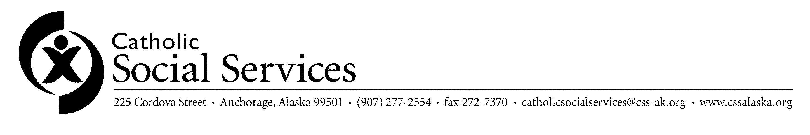

PHOTOGRAPH/VIDEO RELEASE AND CONSENT FORM

I hereby grant to Catholic Social Services the right and permission to use and/or publish my or my family members’ photograph, voice and/or image in any media for promotion of Catholic Social Services’ programs, advertising or other lawful purpose.

Media will be defined to include photographic, audio, visual, electronic, or combined recordings of CSS facilities, clients and staff in any medium in which a likeness, voice, or discussion may be recorded in print, audio or visual, electronic or display. Media includes newspapers/magazines (articles and advertising), radio (audio recordings), television (live and/or video recordings); print media such as brochures, newsletters, etc.; other electronic media such as web sites on the Internet; and other visuals such as displays.

I hereby waive any right to inspect or approve the finished product or the advertising text that may be used in connection therewith, or the use to which it may be applied.

I release, discharge, and agree to hold harmless Catholic Social Services, or its program, from any liability or financial obligation by virtue of any use whatsoever of said photographs or images.

Name(s)______________________________________________________________

Signature_____________________________________________________________

Date_________________________________________________________________

